Lab4
Task4
#include <stdio.h>

int main() {
int score;

printf("Enter the student's score: ");
scanf("%d", &score);

if (score >= 90) {
printf("Grade: A\n");
}
else if (score >= 80) {
printf("Grade: B\n");
}
else if (score >= 70) {
printf("Grade: C\n");
}
else if (score >= 60) {
printf("Grade: D\n");
}
else {
printf("Grade: F\n");
}

return 0;
}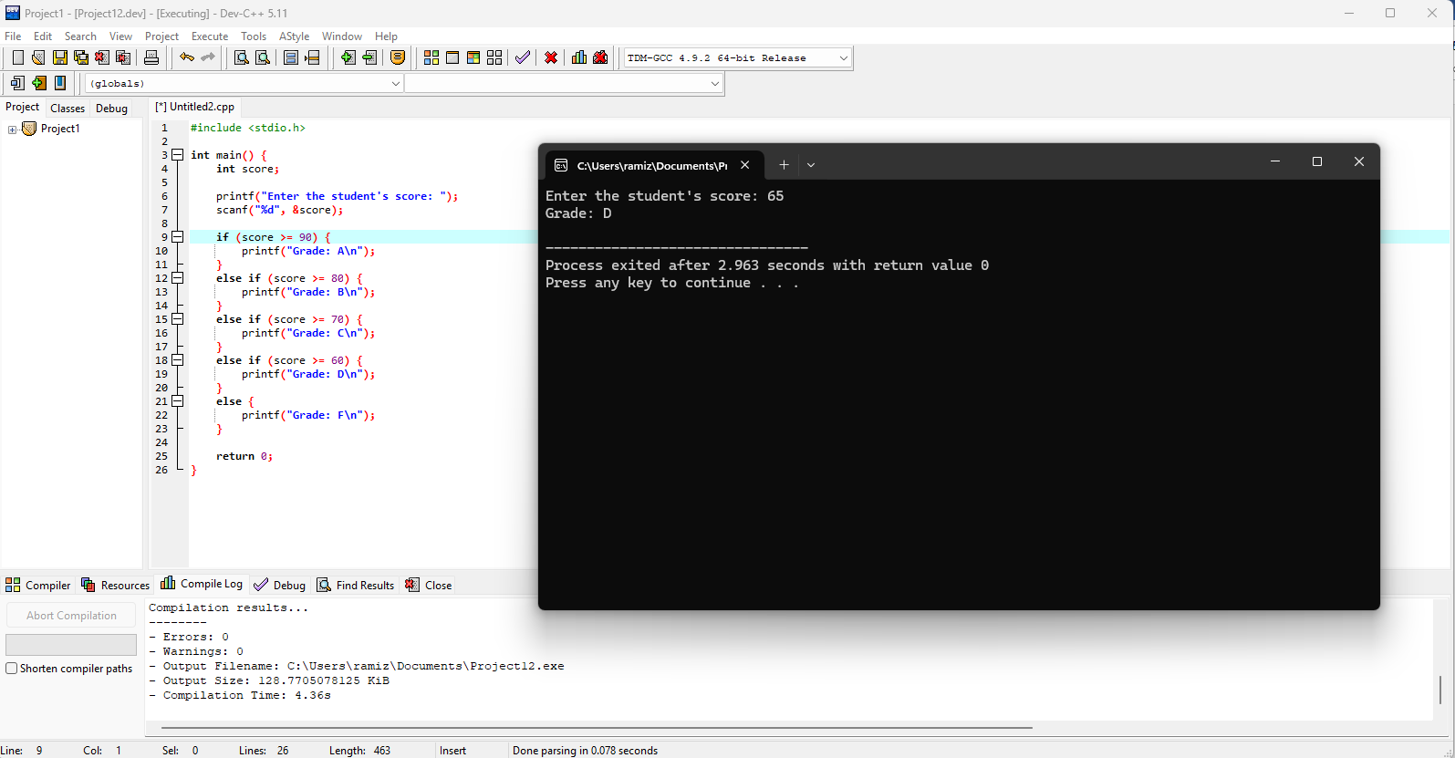

Task5
#include <stdio.h>

int main() {
int color;

printf("Enter traffic light color (1 for Red, 2 for Yellow, 3 for Green): ");
scanf("%d", &color);

switch (color) {
case 1:
printf("Stop\n");
break;
case 2:
printf("Ready\n");
break;
case 3:
printf("Go\n");
break;
default:
printf("Invalid input! Please enter 1, 2, or 3.\n");
}

return 0;
}
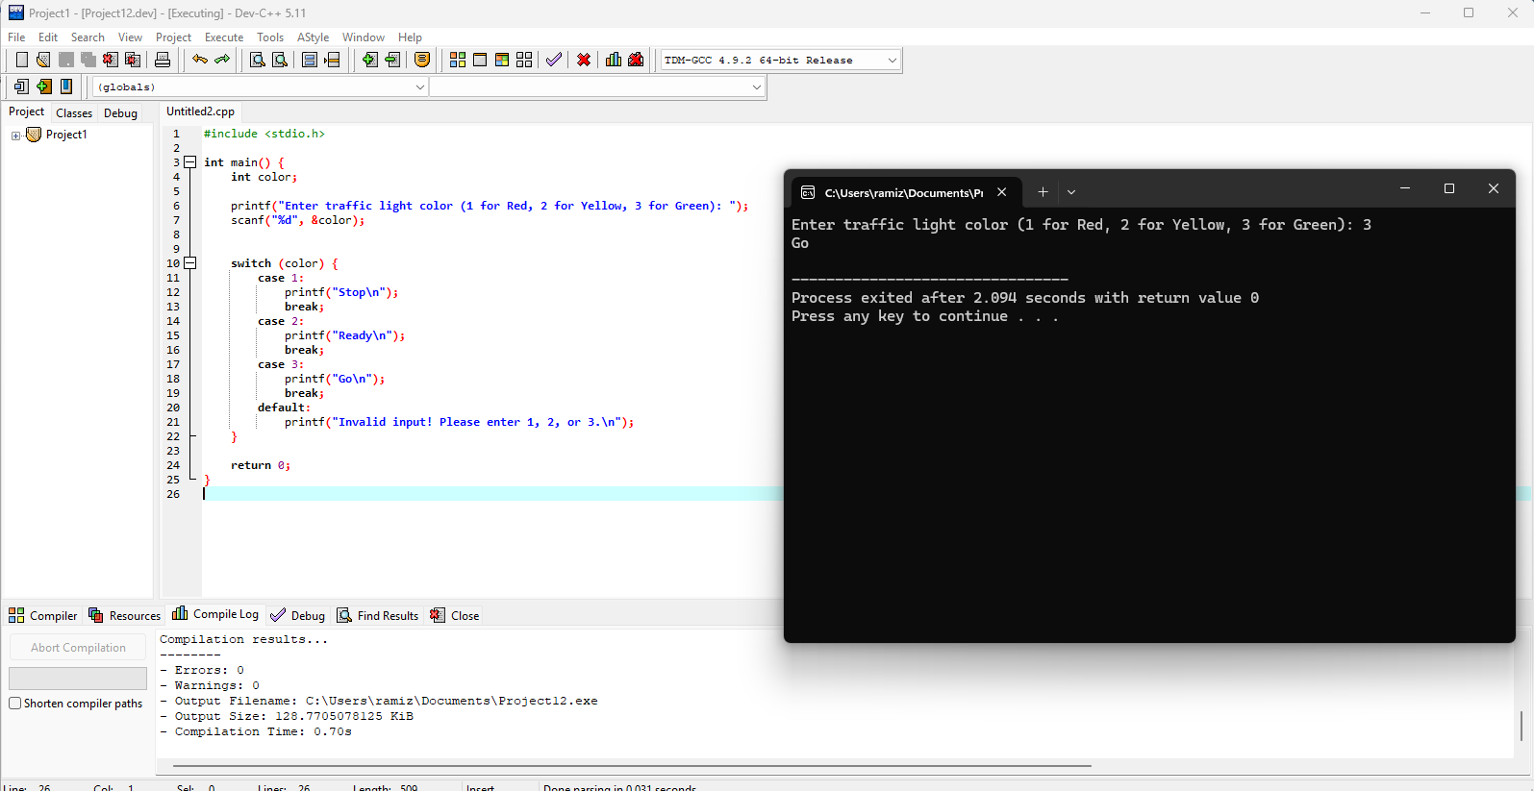

Task6
#include <stdio.h>

int main() {
int num1, num2;
char op;

// Input two integers
printf("Enter first number: ");
scanf("%d", &num1);

printf("Enter second number: ");
scanf("%d", &num2);

printf("Enter an operator (+, -, *, /): ");
scanf(" %c", &op);

switch (op) {
case '+':
printf("Result: %d\n", num1 + num2);
break;
case '-':
printf("Result: %d\n", num1 - num2);
break;
case '*':
printf("Result: %d\n", num1 * num2);
break;
case '/':
if (num2 != 0) {
printf("Result: %d\n", num1 / num2);
} else {
printf("Error: Division by zero is not allowed!\n");
}
break;
default:
printf("Invalid operator! Please enter +, -, *, or /\n");
}

return 0;
}
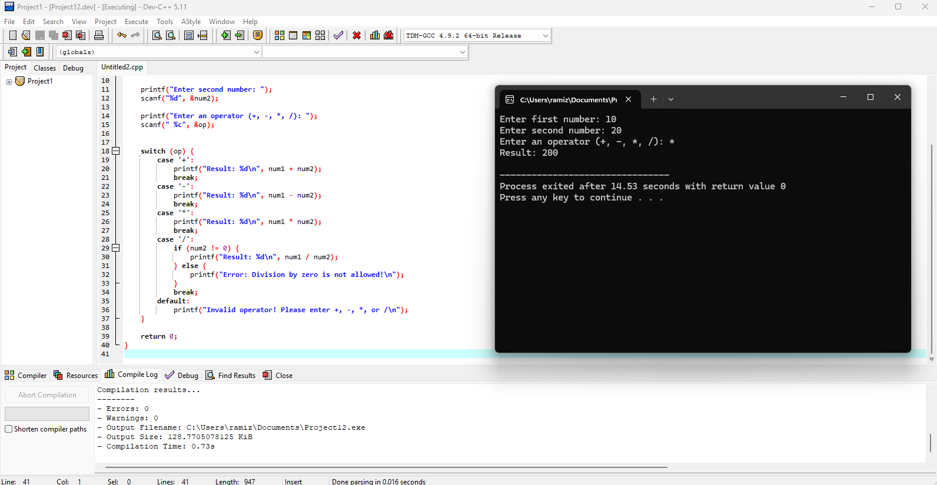

Task7
#include <stdio.h>

int main() {
int year;

printf("Enter a year: ");
scanf("%d", &year);

if ((year % 4 == 0 && year % 100 != 0) || (year % 400 == 0)) {
printf("%d is a Leap Year.\n", year);
}
else {
printf("%d is NOT a Leap Year.\n", year);
}

return 0;
}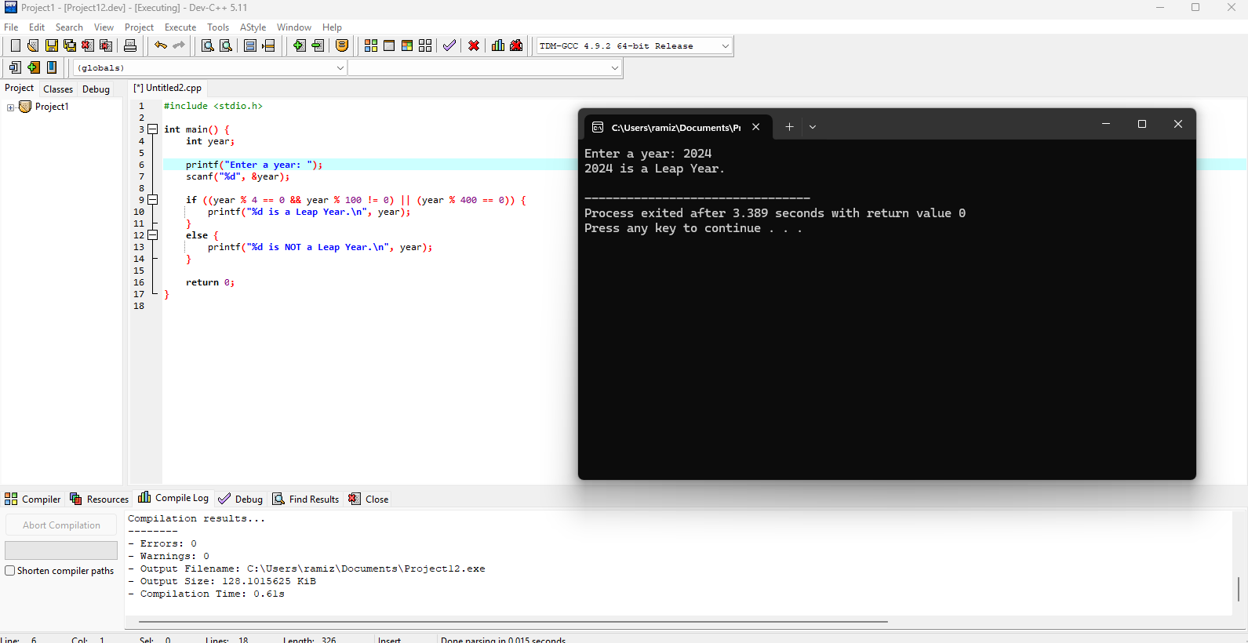

Task8
#include <stdio.h>

int main() {
int num;

printf("Enter a number: ");
scanf("%d", &num);

if (num > 0) {
printf("%d is Positive.\n", num);
}
else if (num < 0) {
printf("%d is Negative.\n", num);
}
else {
printf("The number is Zero.\n");
}

return 0;
}
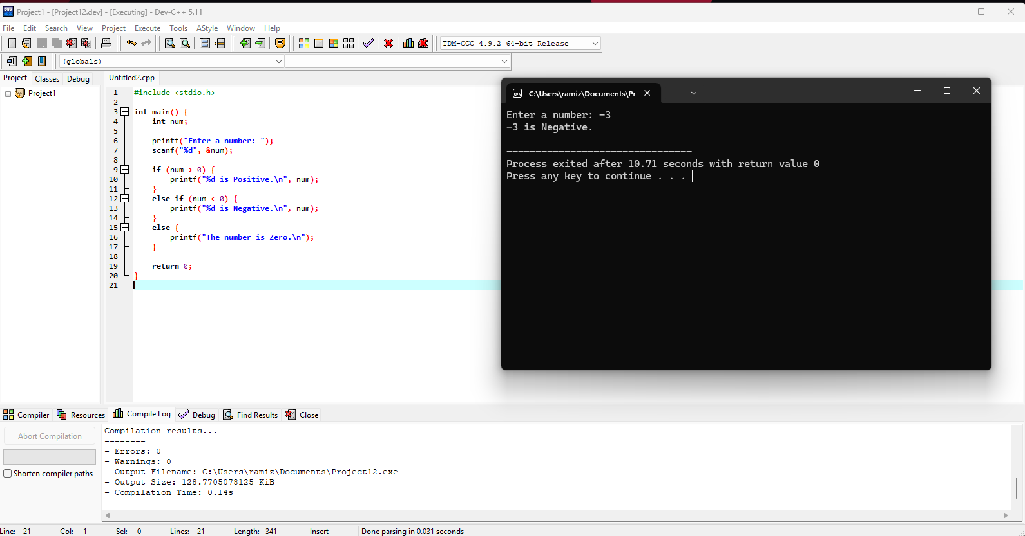

Task9
#include <stdio.h>

int main() {
int day;

printf("Enter a number (1-7): ");
scanf("%d", &day);

switch (day) {
case 1:
printf("Monday\n");
break;
case 2:
printf("Tuesday\n");
break;
case 3:
printf("Wednesday\n");
break;
case 4:
printf("Thursday\n");
break;
case 5:
printf("Friday\n");
break;
case 6:
printf("Saturday\n");
break;
case 7:
printf("Sunday\n");
break;
default:
printf("Invalid input! Please enter a number between 1 and 7.\n");
}

return 0;
}
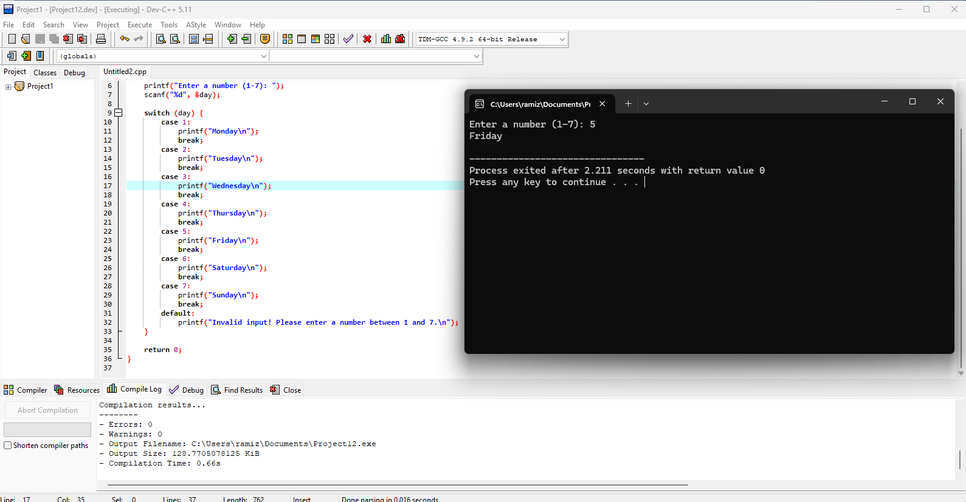

Task10
#include <stdio.h>
#include <string.h>

int main() {
char password[20];
char predefined[] = "Fast1234";

printf("Enter the password: ");
scanf("%s", password);

if (strcmp(password, predefined) == 0) {
printf("Access Granted\n");
}
else {
printf("Access Denied\n");
}

return 0;
}
// learned about string compare and its syntax
// the diffrence b/w == and strcmp is that == only compares memory address not the text
